Review of New Empirical Generalizations on the Determinants of Price Elasticity

By Shitai Zhang

**Meta-Analysis:**

An analysis that combines the result of multiple research paper. The fundamental idea behind this analysis is that that is a common truth behind all studies, but which has been measured with a certain error within individual research. Our aim is to find the truth behind using some statistics. (Basically, find the weighted average)

Key benefit for this analysis is the aggregate of information leading to a higher statistical power and more robust point estimate. The weakness is that research has to make choices that can severely affect the results.

**Aim:**

Updating and extending empirical generalization on price sensitivity by presenting the results of a meta-analysis on the determinant of price elasticity. Compared with Tellis’s paper of meta-analysis of price elasticities published in 1988 (“The Price Elasticity of Selective Demand: A Meta-Analysis of Econometric Models of Sales”).

**Determinants this paper particularly looking into:**

1. ***Market Characteristics:***

Time of data

Manufactural brand vs private label

Product category

Stage of product life cycle

Country

Income

Inflation rate

**Methodology**

1. ***Research Methodology:***

Data source

Temporal aggregation

SKU vs brand level

Criterion variable

Functional form

Price definition

Long-term vs short-term price effect

Endogeneity of price effect

Inclusion of other variables

Estimation method

Heterogeneity in price sensitivity

Gathering all the possible research available and filtered it along with the following criteria:

1. Only about brand and SKU elasticities instead of category sales
2. Elasticity should be about specific single product instead of average across items
3. Only consider the price elasticities based on actual purchase or sales data
4. Limit research to B2P markets

Collect household income and inflation rate from credible institutes.

**Model:**

Considering within-study error correlations between price elasticities, the author model price elasticity as a hierarchical linear model of the determinant. To do hierarchical linear modelling, he firstly conducted a principal components analysis for categorical variables.

**Results**

As showed in figure 2, the distribution of price elasticity is densely populated between 0 and -4. And pooled weight average across all the studies give us the mean price elasticity at -2.62 with median = -2.22 and standard deviation= 2.21.

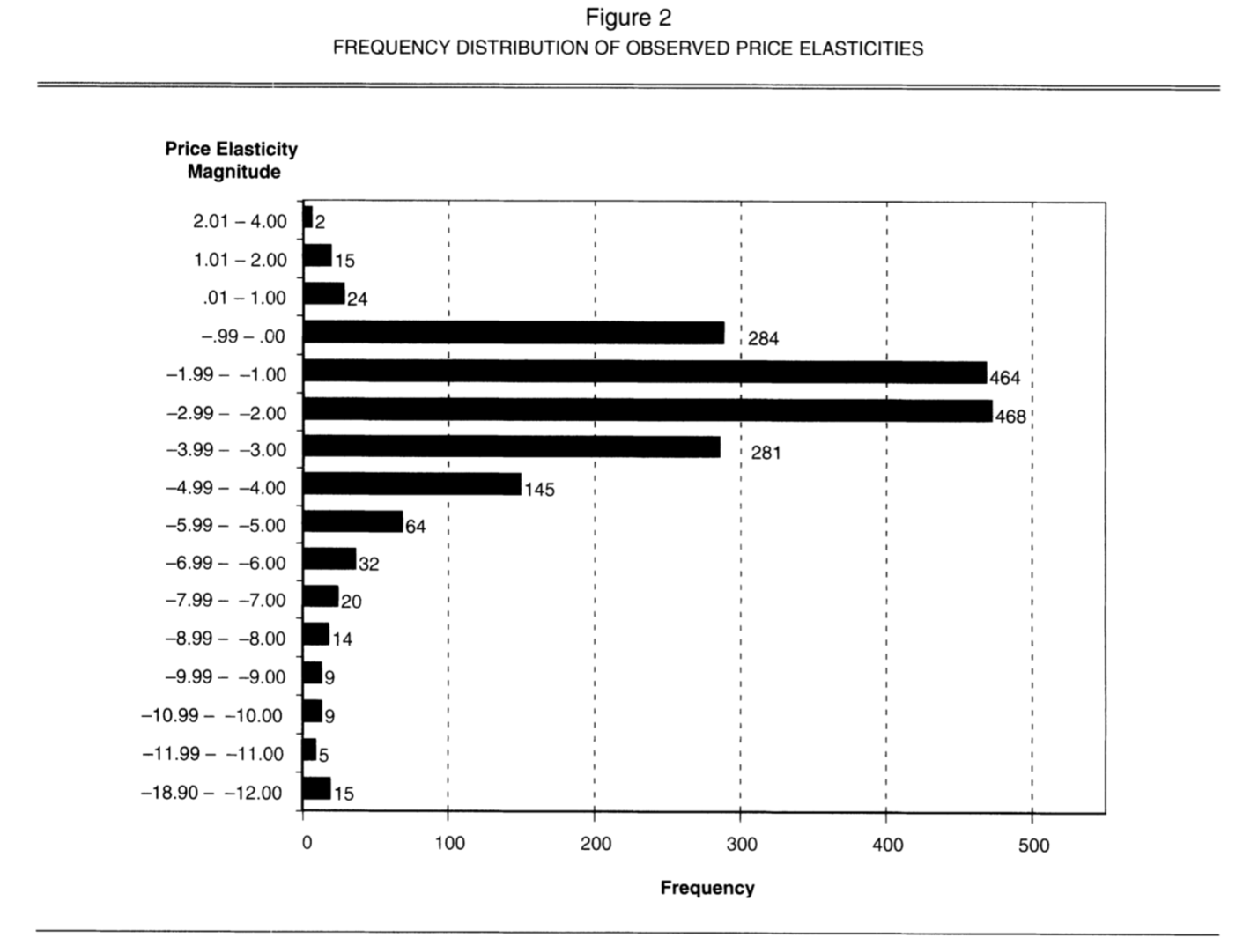

The HLM gives us a satisfactory result with R^2= 0.16 and significant f-value. Coefficients of determinant was listed in table2:

We only take some striking findings to discuss:

1. In the past decades, the market saw a shift of marketing money from advertising (increase differentiability and thus should decrease price elasticity) to promotion (significant short-term benefit, while in long-term increase consumers’ price elasticity). As expected, there should be a significant negative correlation between price elasticity and year of data collection. While year alone is not significant, the interaction term of year and sales elasticity is significant. And beta is equals -0.05, which implies that for every 20 years, the elasticity of sales to price will increase by 1%.
2. Higher price elasticity for durable goods and during introduction/growth stage than in the mature/decline stage (indicates deeper differentiation as product category became matured).
3. Positive correlation between inflation rate and price elasticity, which indicates high inflation rates make consumer aware of and sensitive to price changes.

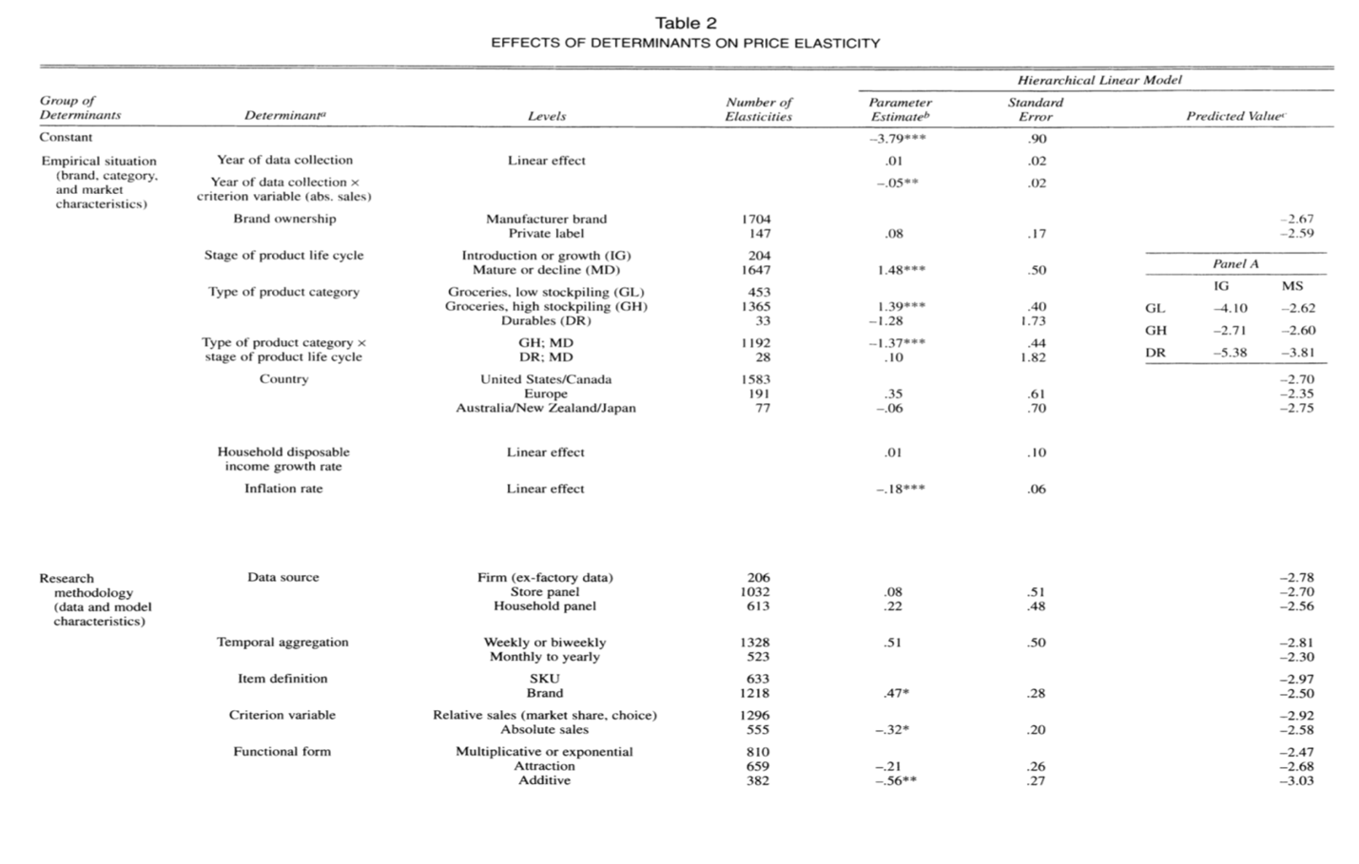

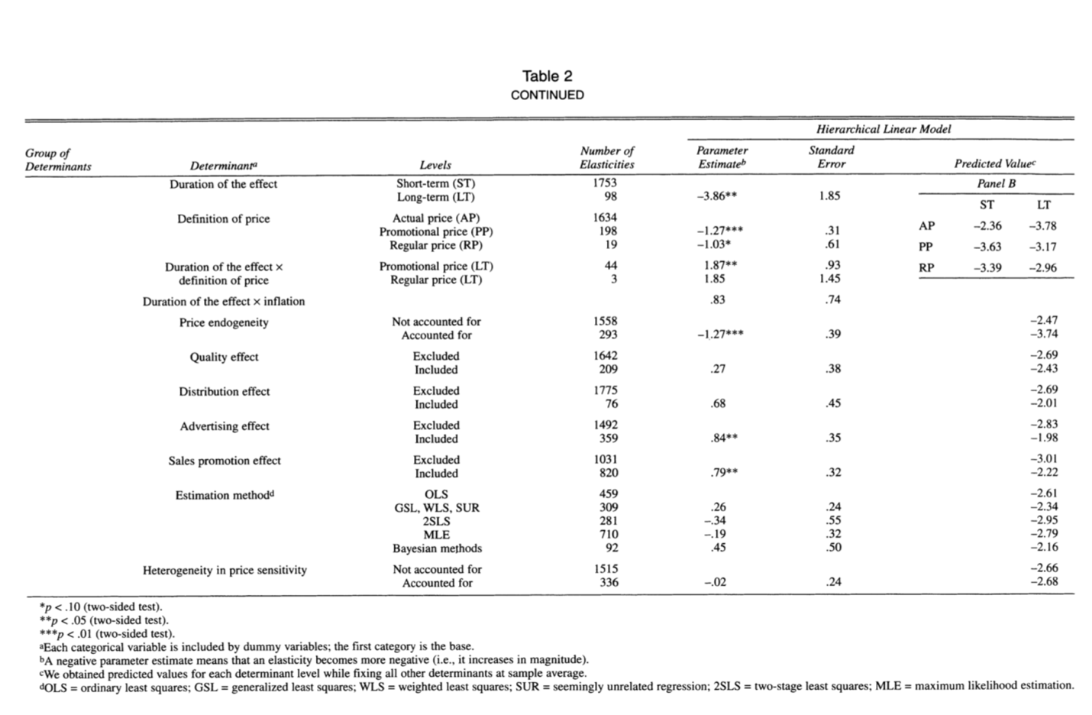

1. SKU vs brands, higher elasticity for SKU than brand aligns with our expectation
2. For short-term, actual price elasticity is lower than promotion price elasticity. While in the long run, it is opposite.
3. Heterogeneity is not a big deal.

**Temporal Patterns in price elasticity:**

Split the sample into two periods: 1956-1979 and 1980-1999 based on the year of data collection. This is because the introduce of scanning.

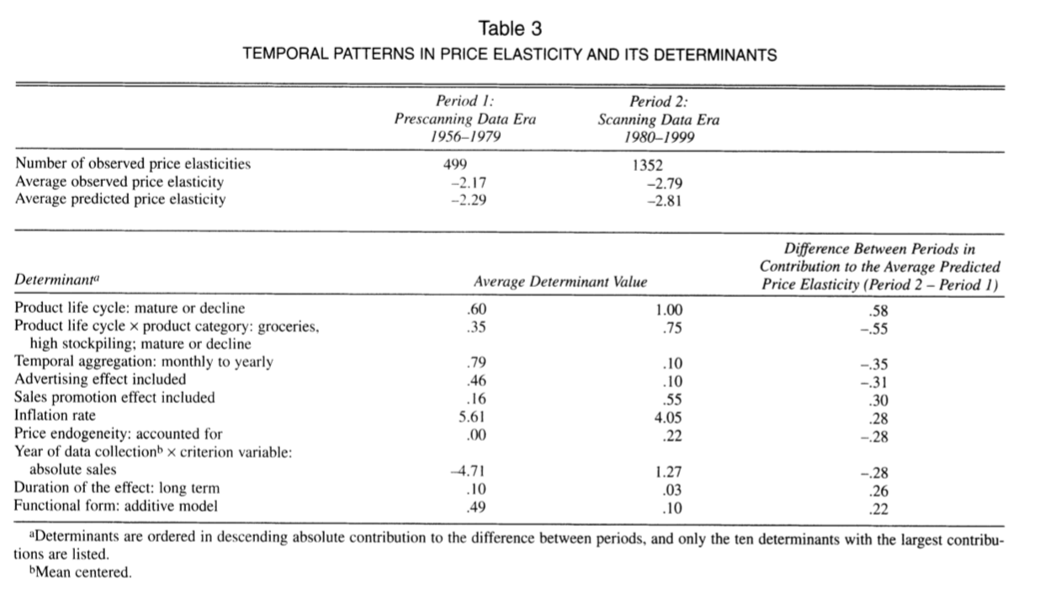

Implications for **managers:**

This research suggests consumers make their decisions on quantity and timing more and more on price, which suggest a deal-to-deal buying behavior. Manager can decrease the frequency of price promotion to accommodate to this problem.

Strongest price elasticity for growth stage products suggests that when introduce a new category, penetration pricing strategy is better than skimming price strategy.

Implications for **researchers**

Include endogeneity! Other than price variables, researcher should also include advertising and sales promotion variables as predictor of price elasticity.

Further research and limitation: